**ASSESSMENT 07**

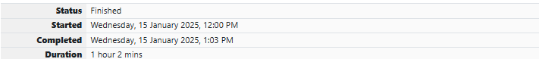

**QUESTION 1**

Take a number, reverse it and add it to the original number until the obtained number is a palindrome.

**Constraints**

1<=num<=99999999

**Sample Input 1**

32

**Sample Output 1**

55

**For example:**

| **Input** | **Result** |
| --- | --- |
| 32 | 55 |
| 1234 | 5555 |

**SOURCE CODE**

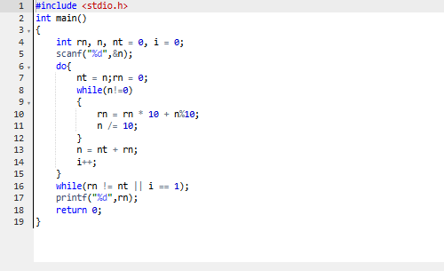

**OUTPUT**

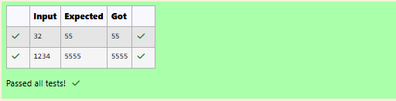

**QUESTION 2**

Write a program to find if a given number N can be expressed as a sum of two prime numbers.

Note: YOU MUST OPTIMIZE the logic to find whether a number is prime or not, as very large prime numbers are provided as input. If the logic is not optimized your program will NOT get executed within the given time limit.

**Input Format:**

First line contains total number of test cases, denoted by T.

Next T lines will contain the value of N for each test case.

**Output Format:**

T lines containing either yes or no.

**Boundary Conditions / Constraints:**

1 <= T <= 25

3 <= N <= 10^9

**Example Input/Output 1:**

**Input:**

5

20

12

23

34

16

**Output:**

yes

yes

no

yes

yes

**Explanation:**

20 can be expressed as 17+3

12 can be expressed as 7+5

23 cannot be expressed as sum of two primes

34 can be expressed as 31+3 or 11+23 or 17+17

16 can be expressed as 11+5

**SOURCE CODE**

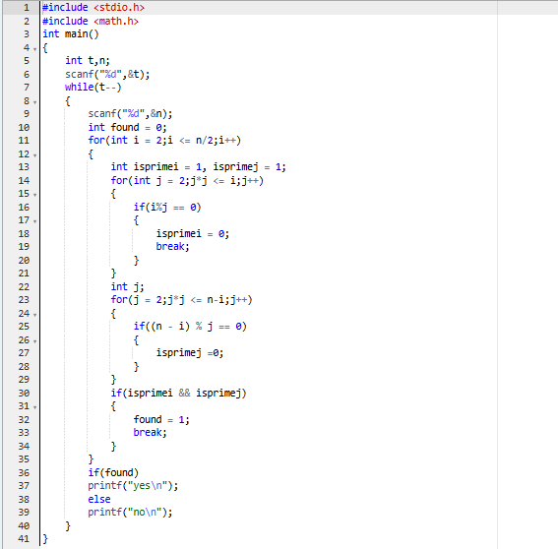

**OUTPUT**

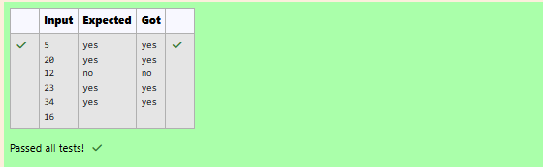

**QUESTION 3**

Write a C program that given an integer ‘n’, prints the number of integers that are less than or equal to ‘n’ and co-prime to ‘n’

Two integers a and b are said to be relatively prime or co-prime if the only positive integer that evenly divides both of them is 1. That is, the only common positive factor of the two numbers is 1. This is equivalent to their greatest common divisor being 1.

Input Format:

One line containing the value of 'n', where 1<=n<=10,000

Output Format:

One line containing the number of integers that are co-prime to n and less than or equal to 'n'

Sample Test Cases

Test Case 1

Input

10

Output

4

Test Case 2

Input

23

Output

22

Test Case 3

Input

11

Output

10

**SOURCE CODE**

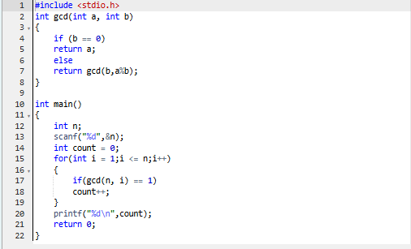

**OUTPUT**

